







**ДОМАЋИ ЗАДАТАК:**

**Илуструјте песму**

**,,Први снег,,**

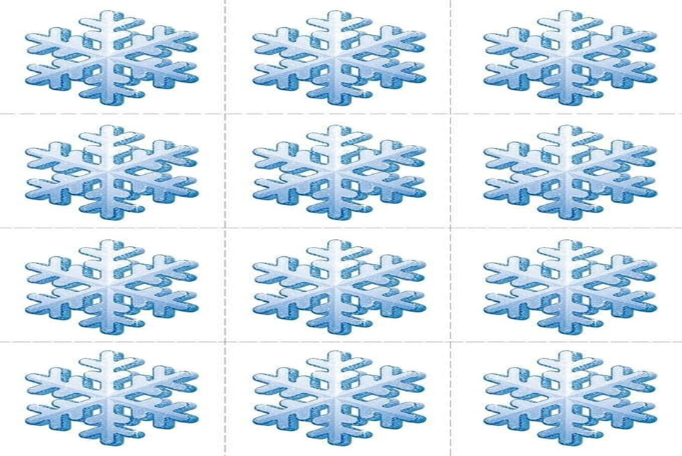

**ДОМАЋИ ЗАДАТАК:**

**Илуструјте песму**

**,,Први снег,,**

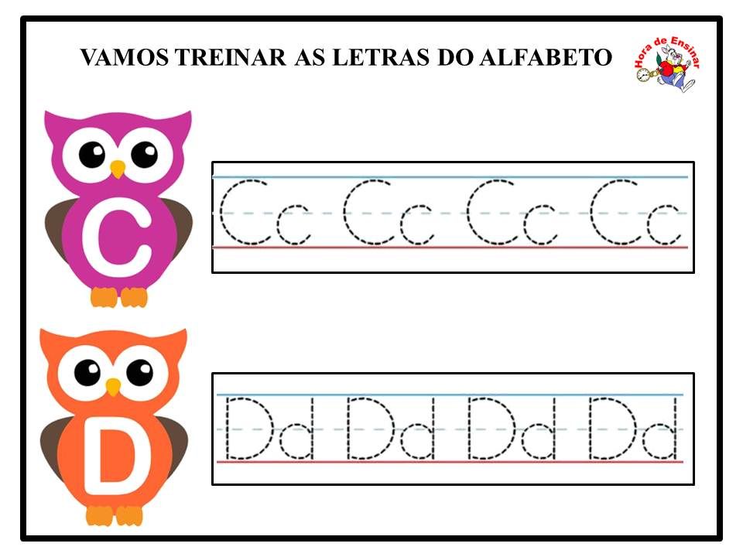

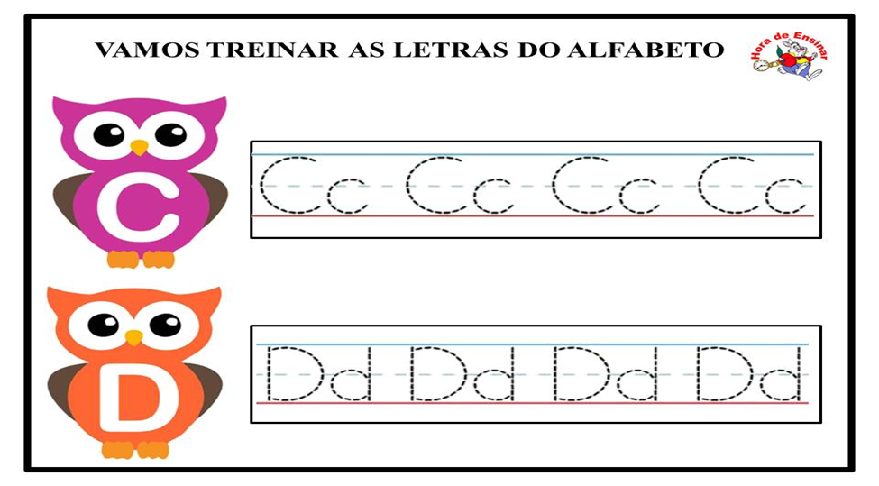

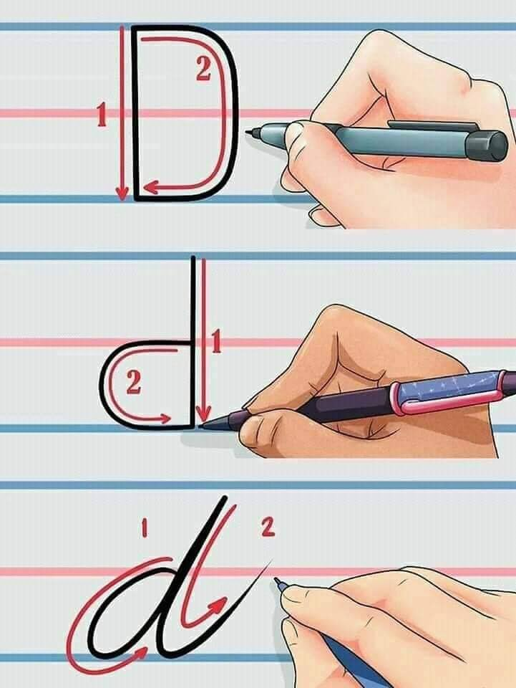

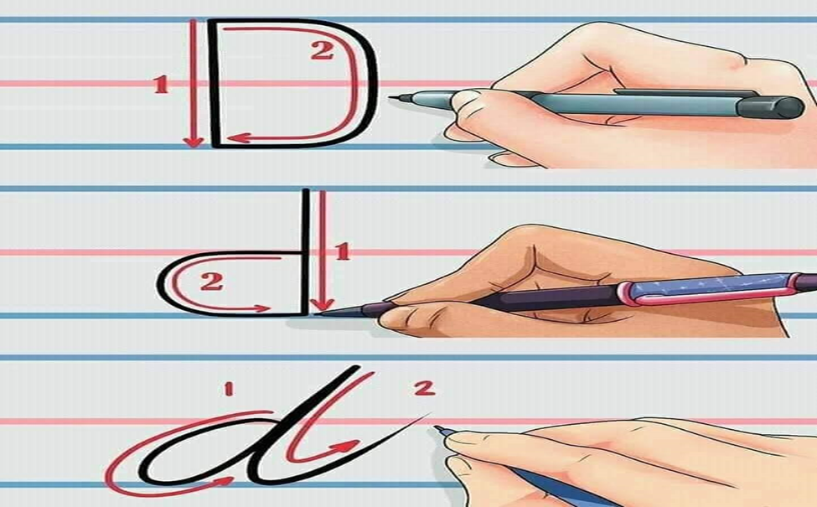





|  |
| --- |
| Реши задатке на два начина:  а) 6 · (3 + 2) = ____________________________________________  6 · (3 + 2) = ____________________________________________  б) 5 · (2 + 8) = ____________________________________________  5 · (2 + 8) = ____________________________________________  в) 4 · (1 + 7) = ____________________________________________  4 · (1 + 7) = ____________________________________________ |
| Реши задатке на два начина:  а) 6 · (3 + 2) = ____________________________________________  6 · (3 + 2) = ____________________________________________  б) 5 · (2 + 8) = ____________________________________________  5 · (2 + 8) = ____________________________________________  в) 4 · (1 + 7) = ____________________________________________  4 · (1 + 7) = ____________________________________________ |
| Реши задатке на два начина:  а) 6 · (3 + 2) = ____________________________________________  6 · (3 + 2) = ____________________________________________  б) 5 · (2 + 8) = ____________________________________________  5 · (2 + 8) = ____________________________________________  в) 4 · (1 + 7) = ____________________________________________  4 · (1 + 7) = ____________________________________________ |